PROJECT TITLE: Omni Retail Global Commerce Ecosystem

Student Name | Reg: I’D
Goveend Kumar | 69504

Motivation:

In the age of data-driven applications, efficient management, storage, and retrieval of information are crucial. The primary objective of this lab is to provide students with hands-on experience in designing, implementing, and managing databases for real-world applications. By focusing on DBMS concepts, students will learn to structure data, enforce constraints, and optimize queries, ensuring data integrity and scalability. This lab bridges theoretical knowledge with practical application, equipping students with essential skills for modern database solutions.
Omni Retail is a rapidly expanding multinational e-commerce organization operating across multiple countries, regional warehouses, payment gateways, shipping partners, and supplier networks. This lab involves redesigning its data infrastructure to solve real-world anomalies, enforce 3NF normalization, implement stored procedures, triggers, and advanced analytical queries.

Problem Statement:

The Omni Retail Global Commerce Ecosystem database is a relational database system designed to manage global retail operations efficiently. The project requires calculating a unique Seed Number (SN) from group member registration IDs and using it to guide the database design. The system includes nine core entities: Customers, Orders, Products, Warehouses, Suppliers, Payments, Shipments, Employees, and Regions, along with two additional entities for SN = 3: Discounts and Claims. The database must be populated with realistic data that includes group member registration IDs and intentionally contains negative stock values in the WarehouseInventory table as a predefined anomaly. Advanced SQL queries are implemented for anomaly detection and business analytics, while a CreateOrder() stored procedure and a Payments audit trigger automate order processing and transaction tracking.

Design / Ways & Means:

Introduction and Requirements:

This project implements the Omni Retail Global Commerce Ecosystem database for a group with the following members:

Member Name | Registration ID | Digit Sum | Contribution
Goveend  Kumar | 69504 | 6+9+5+0+4 = 24 | Schema Design, SQL Queries
Jawad Ali | 68626 | 6+8+6+2+6 = 28 | Data Population, Testing

The Seed Number was calculated by extracting all digits from each Registration ID and summing them: 69504 gives 6+9+5+0+4 = 24, and 68626 gives 6+8+6+2+6 = 28, for a combined total of 52. Applying the modulo operation, 52 MOD 7 = 3, giving a Seed Number of 3. Consequently, the database is named Retail_3, the two additional mandatory entities are Discounts and Claims, and the required data anomaly is negative stock values in the WarehouseInventory table.

Basic Implementation:

The database Retail_3 was created using SQL Server and consists of 13 tables covering all mandatory and SN-specific entities. The schema uses Primary Keys, Foreign Keys, CHECK constraints, DEFAULT values, and UNIQUE constraints as required. All tables were created and populated in the correct dependency order.

Registration ID Embedding Map:

Reg ID | Embedded In | Column | Sample Value
69504 | Products | ProductCode | PRD-69504
68626 | Shipments | TrackingNumber | TRK-68626

Performance Testing and Analysis:

All SQL queries were tested on the Retail_3 database using SQL Server Management Studio (SSMS). Performance was measured by analyzing query plans and execution times. The tri-approach Task 2 queries (JOIN, Correlated Subquery, Window Functions) were compared for efficiency. The JOIN-based approach proved most performant for large datasets due to set-based operations, while correlated subqueries showed row-by-row overhead.

Optimization and Advanced Features:

Advanced features implemented include:

  - Stored Procedure CreateOrder(): Validates stock, deducts inventory, creates order, payment, and shipment records atomically within a transaction.
  - Trigger trg_payment_update: Fires AFTER UPDATE on Payments table, logs old/new amounts, DB user, and timestamp to AuditLog — but suppresses duplicate entries when triggered from CreateOrder() via SESSION_CONTEXT.
  - AuditLog Table: Captures all manual payment modifications for financial governance.
  - Window Functions: Used in Task 2 Version 3 for efficient regional average computation using PARTITION BY.

Extensions and Creativity:

Beyond the minimum requirements, this implementation includes:

  - 30 products (33 total) instead of the minimum 30, with extended product categories.
  - OrderDetails table for granular order-product linkage.
  - Three complete test cases for CreateOrder() covering success, insufficient stock, and invalid product scenarios.
  - Complete anomaly verification queries that identify and summarize all negative stock records.
  - A comprehensive final record count summary query using UNION ALL across all 14 tables.

Deliverables:
  - SQL Script: Complete schema DDL, INSERT statements, stored procedure, trigger, AuditLog, and all analytical queries for database Retail_3.
  - Document Report: SN calculation, Registration ID embedding map, 3NF justification, Task 2 performance comparison, and screenshots of all query outputs.

  - ER Diagram: Entity-Relationship diagram showing all 13 tables and their relationships.
  - Relational Schema: Full relational schema with primary and foreign key notations.
  - SQL Query Screenshots: Output screenshots for all queries, stored procedure tests, and audit log verification.

Background:
The Omni Retail Global Commerce Ecosystem is a multinational e-commerce platform that has grown without proper data governance, leading to inconsistent business rules and overlapping application logic. This project represents a clean-room redesign of the database layer, applying relational theory, normalization, and modern SQL features to produce a production-grade schema.
The system covers five geographical regions (Sindh, Punjab, Dubai, Riyadh, London), operates 10 warehouses, manages 30+ products across multiple categories, tracks 40+ orders, and maintains full payment and shipment records. The SN=3 anomaly of negative stock values in WarehouseInventory simulates real-world inventory mismanagement scenarios that the detection queries are designed to identify.

ER Diagram
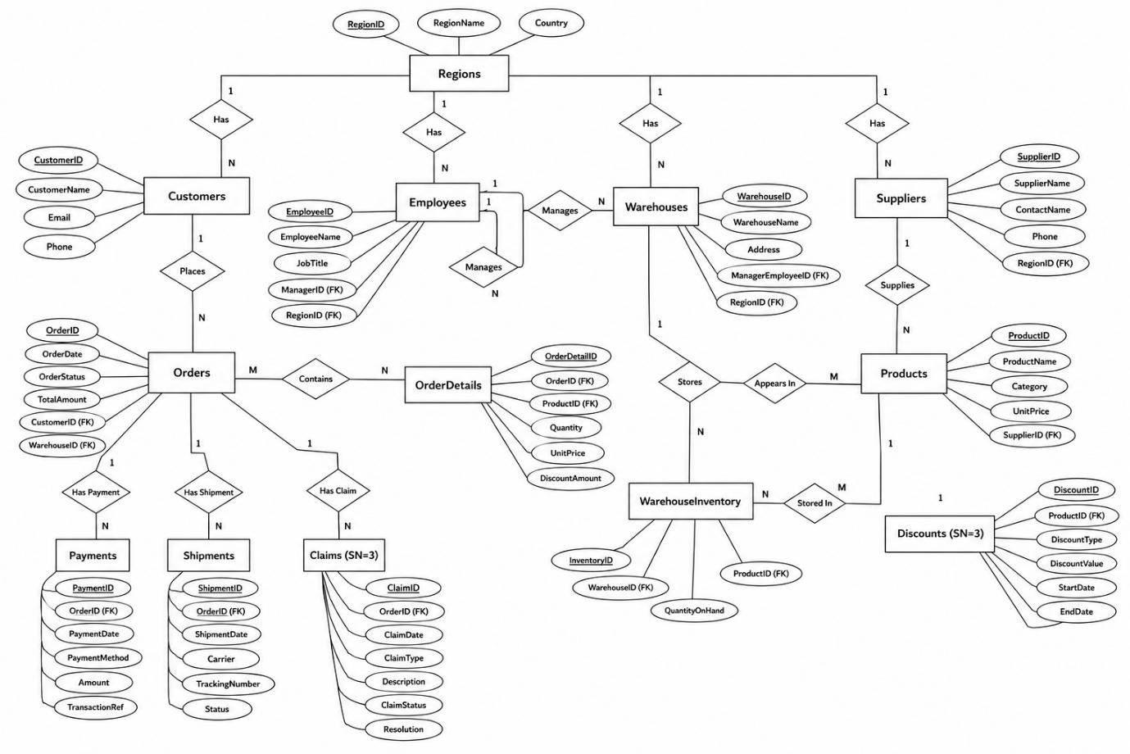

Relational Schema
The following relational schema represents the complete Retail_3 database design in 3NF:

Regions(RegionID PK, RegionName, Country, Currency)
Customers(CustomerID PK, FullName, Email UNIQUE, Phone, DateOfBirth, RegistrationDate DEFAULT, RegionID FK→Regions)
Employees(EmployeeID PK, FullName, JobTitle, ManagerID FK→Employees(self), HireDate, RegionID FK→Regions)
Warehouses(WarehouseID PK, WarehouseName, RegionID FK→Regions, Capacity CHECK>0, ManagerEmployeeID FK→Employees)
Suppliers(SupplierID PK, SupplierName, ContactEmail, RegionID FK→Regions, ContractStartDate)
Products(ProductID PK, ProductCode UNIQUE, ProductName, Category, UnitPrice CHECK>0, SupplierID FK→Suppliers, StockQuantity DEFAULT 0)
Orders(OrderID PK, CustomerID FK→Customers, OrderDate, TotalAmount, Status DEFAULT 'Pending', WarehouseID FK→Warehouses)
OrderDetails(OrderDetailID PK, OrderID FK→Orders, ProductID FK→Products, Quantity, UnitPrice)
Payments(PaymentID PK, OrderID FK→Orders, PaymentDate, Amount, PaymentMethod, Status)
Shipments(ShipmentID PK, TrackingNumber, OrderID FK→Orders, ShipDate, DeliveryDate, TransportCost, CarrierName)
Discounts(DiscountID PK, ProductID FK→Products, DiscountPercent, StartDate, EndDate) Claims(ClaimID PK, OrderID FK→Orders, ClaimDate, ClaimReason, Status)
WarehouseInventory(InventoryID PK, WarehouseID FK→Warehouses, ProductID FK→Products, StockLevel)
AuditLog(AuditID PK IDENTITY, OrderID, OldAmount, NewAmount, DBUser, ChangeTime)

3NF Justification:
All tables satisfy Third Normal Form (3NF) requirements: (1) Every attribute is atomic with no repeating groups — 1NF satisfied. (2) All non-key attributes are fully functionally

dependent on the primary key — 2NF satisfied. (3) There are no transitive dependencies; all non-key attributes depend only on the primary key, not on other non-key attributes — 3NF satisfied. Supplier details are stored in a separate Suppliers table rather than denormalized into Products, and Region information is kept in its own table rather than duplicated across Customers, Employees, Warehouses, and Suppliers.

SQL QUERIES AND Output Screenshots:

The following section presents all SQL queries implemented in the Retail_3 database, organized by functionality.

Database Creation & Comment Block
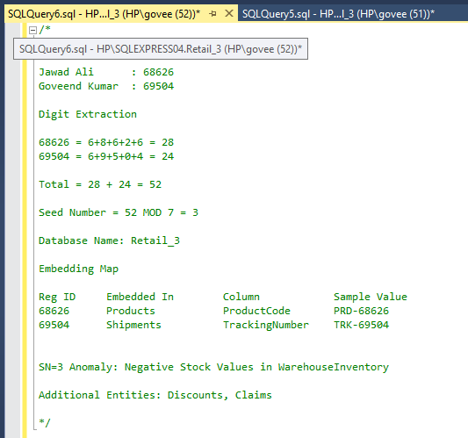
Create database :
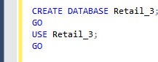

Regions Query:
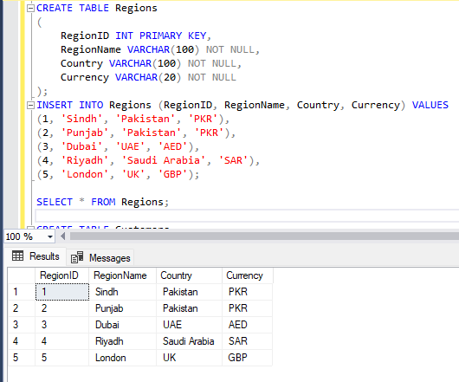

Customer Query:
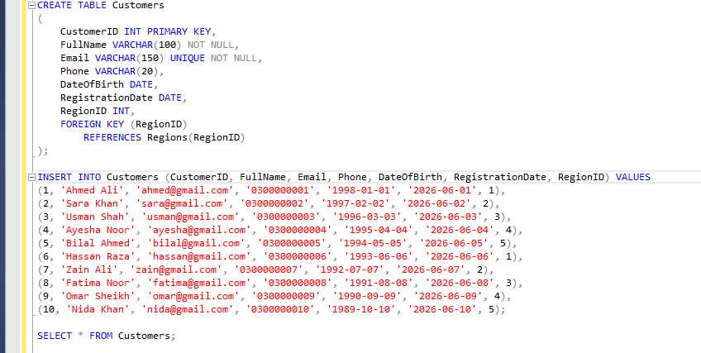

Output:
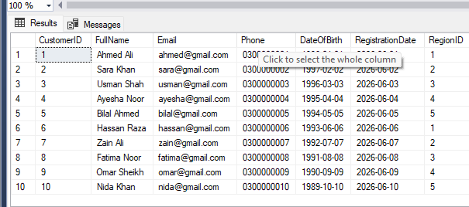

Count Region Customer query: Output:
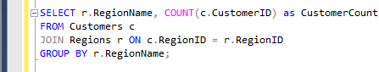
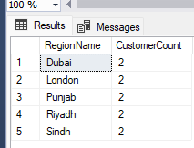

Employee query:
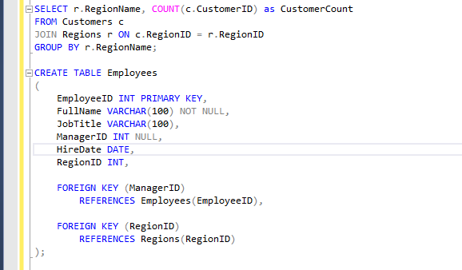

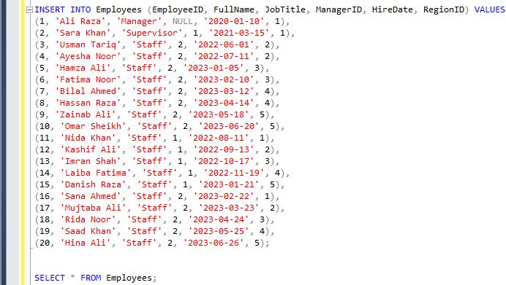

Output:
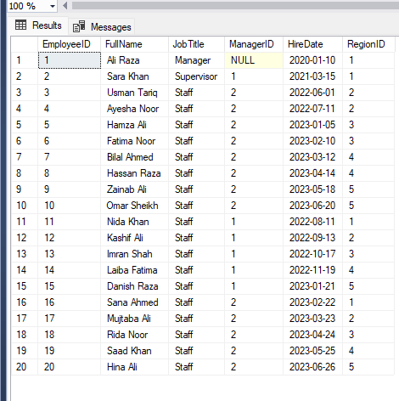

Employee hierarchy query:
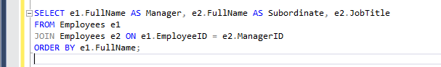

Output:
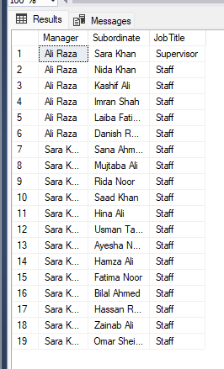

Warehouse Query:
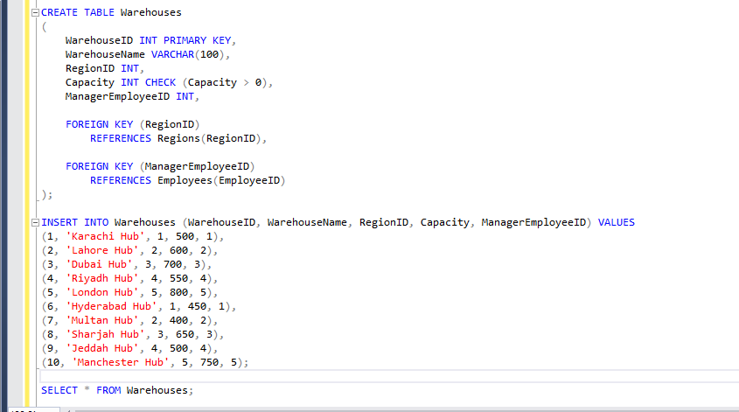

Output:

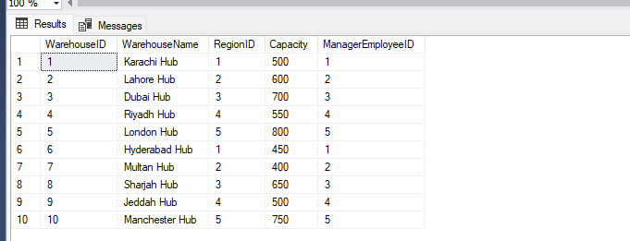
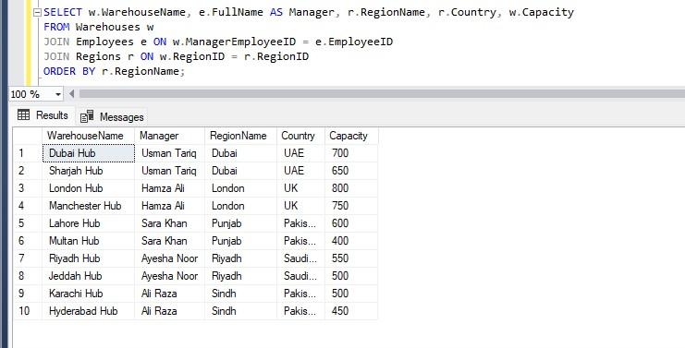

Suppliers:
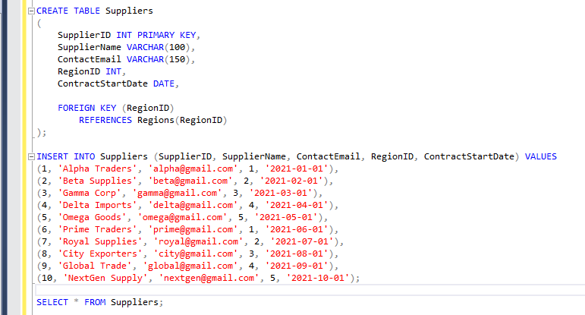

Output:
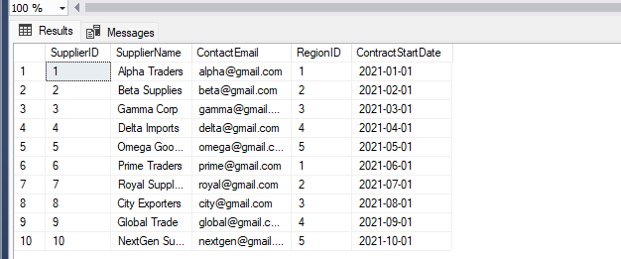

Suppliers by region:
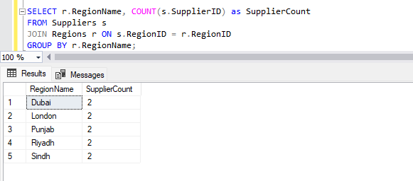

Products:
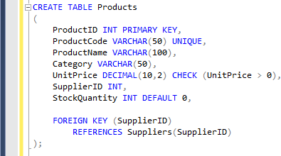
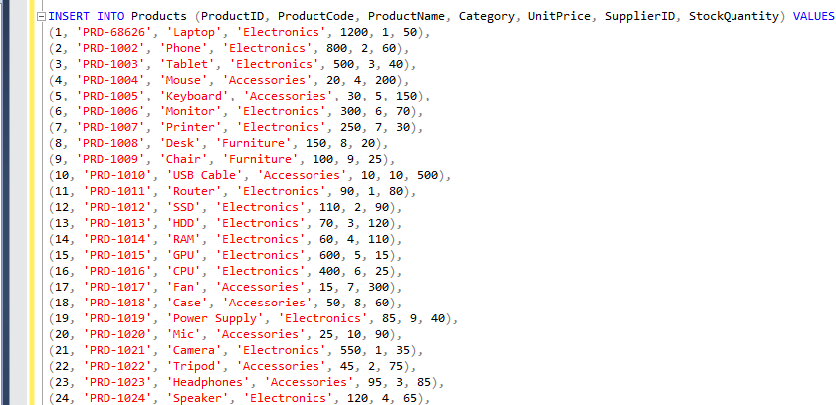

Output:
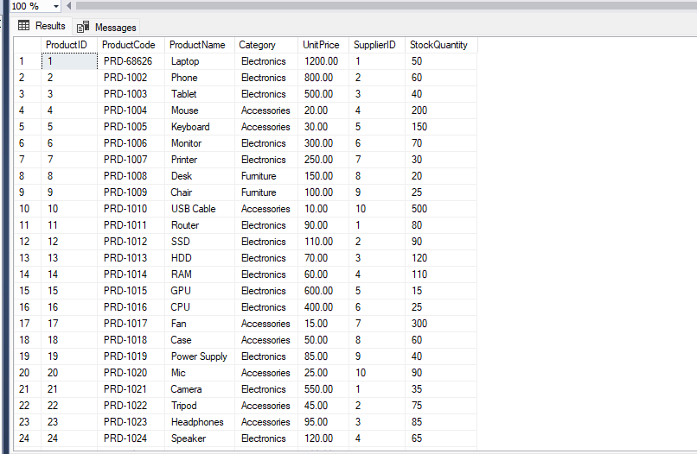

Products by category with average price:
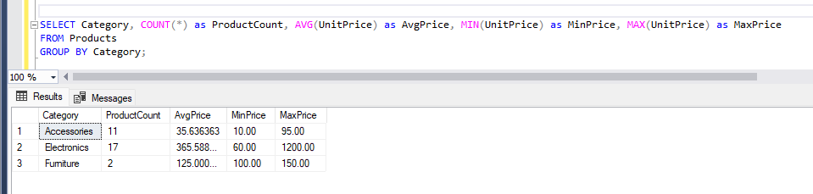

Products with low stock (less than 50):
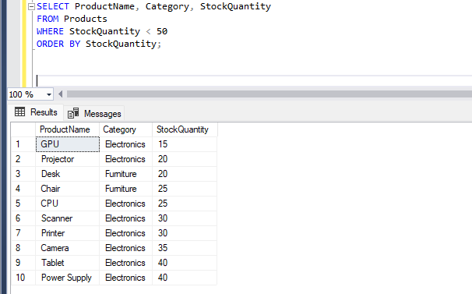

Orders:
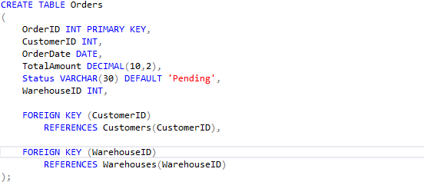
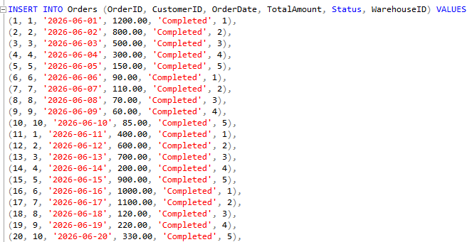
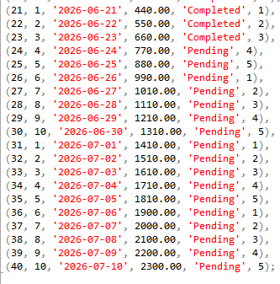

Output:
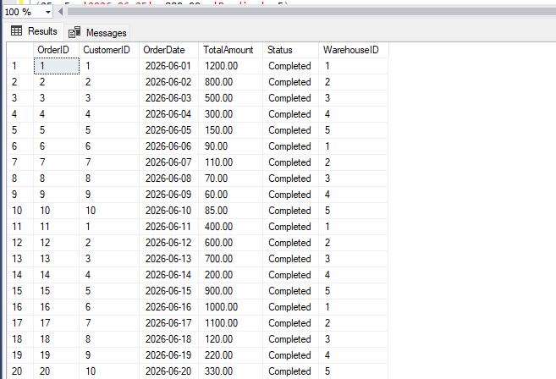
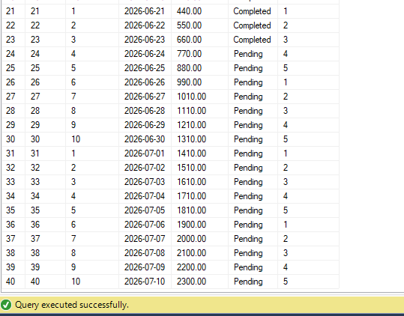

Order summary by status:
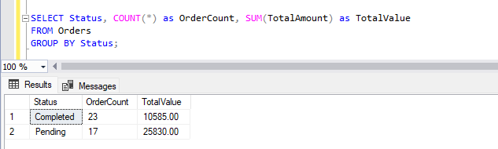

Top 5 customers by order value:
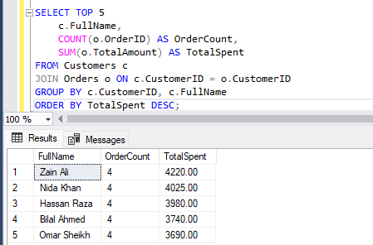

Payment:
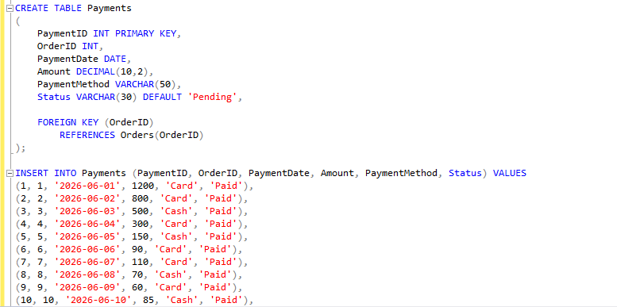

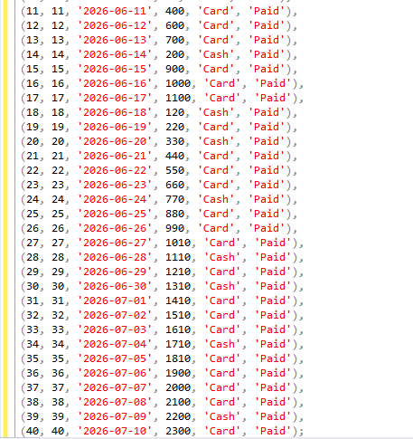

Output:
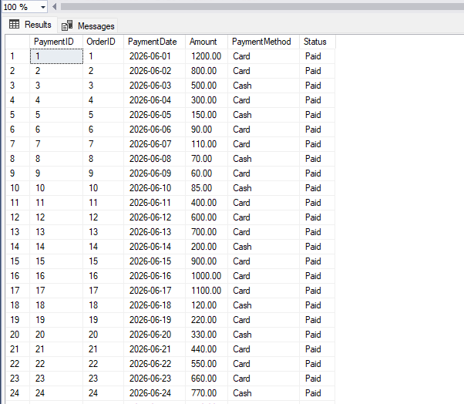
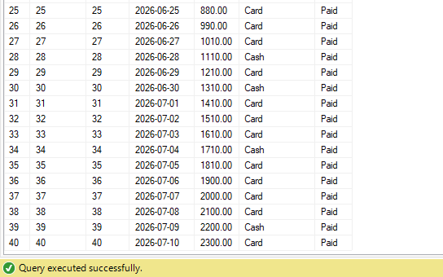

Payment summary by method:
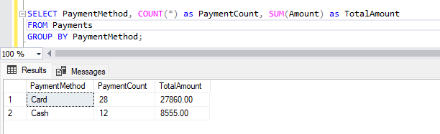
Shipments:
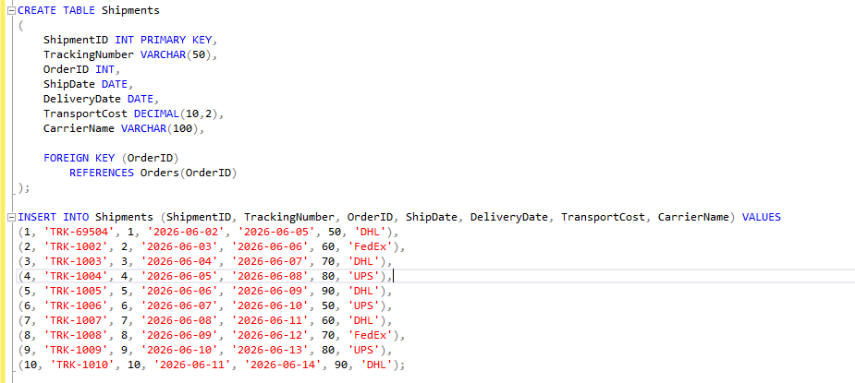

Output:

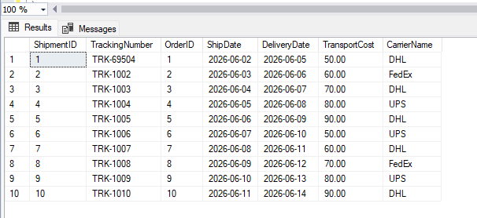

Shipment summary by carrier:
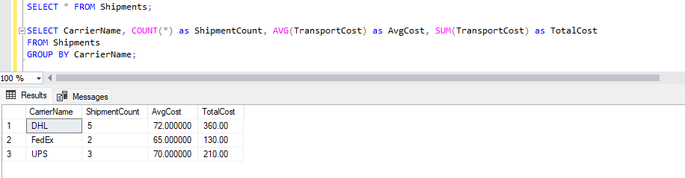

Discounts:
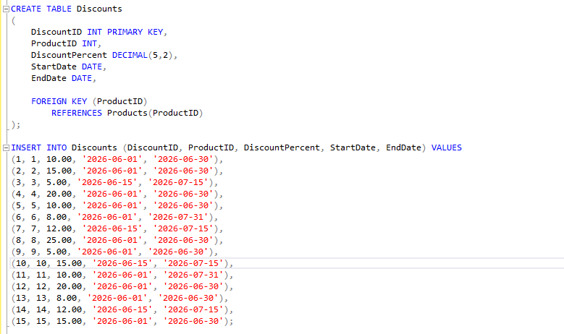

Output:

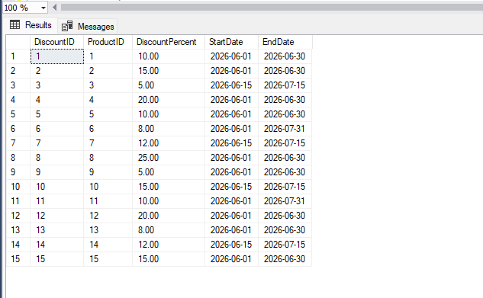

Products with active discounts:
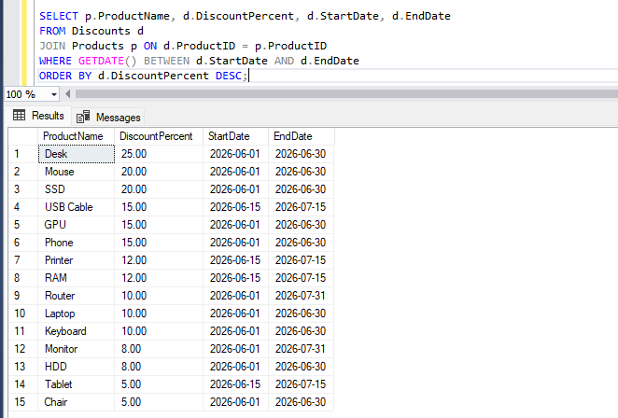

Claims:
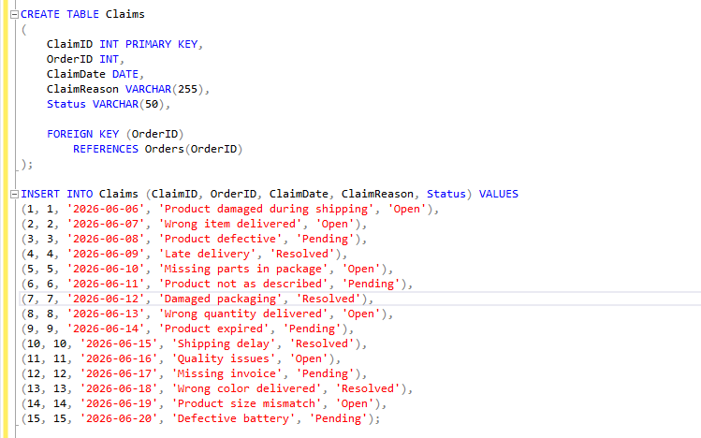

Output:

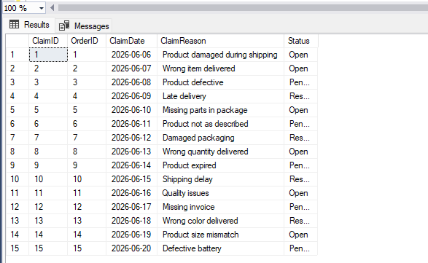

Claim summary by status:
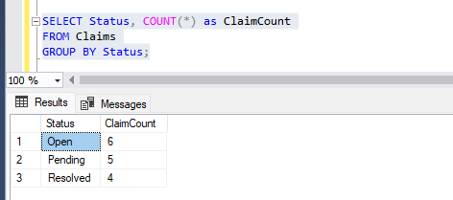

Claims by reason category:
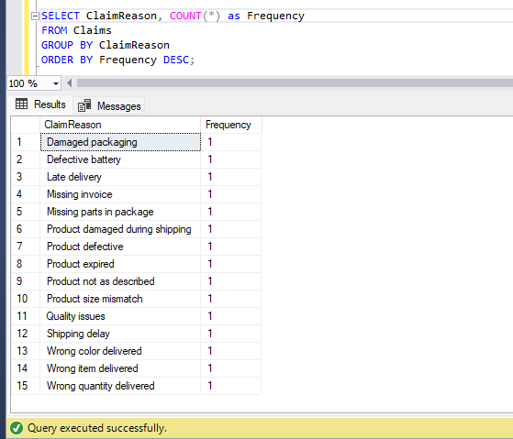

OrderDetails:
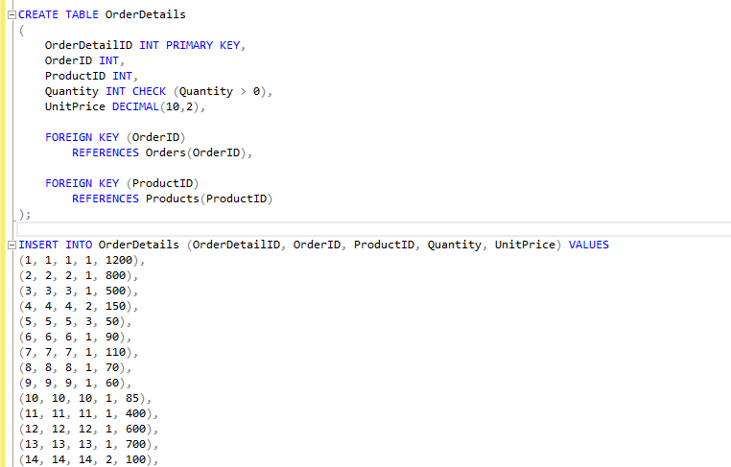
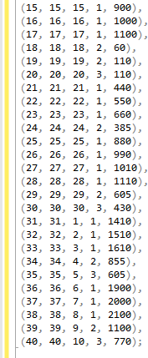

Output:
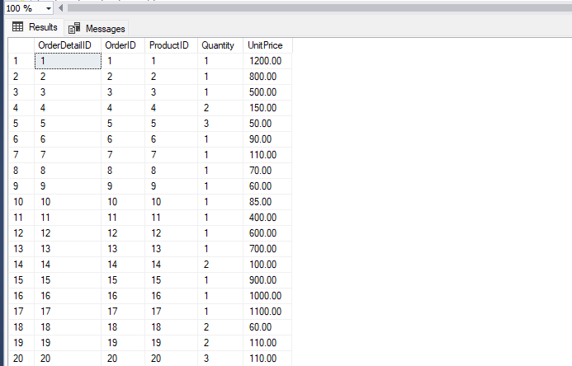
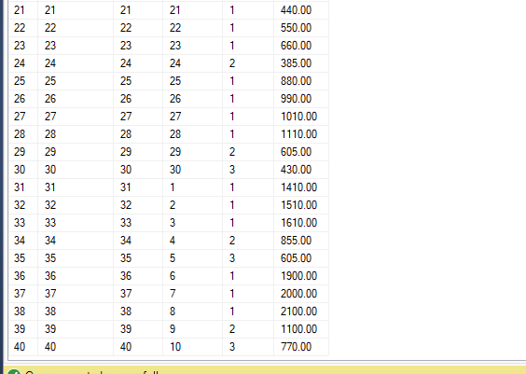

Best Top 10 selling products:
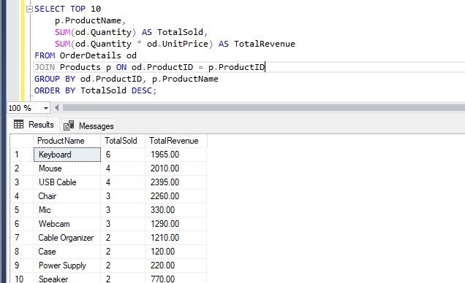

Warehouse Inventory:
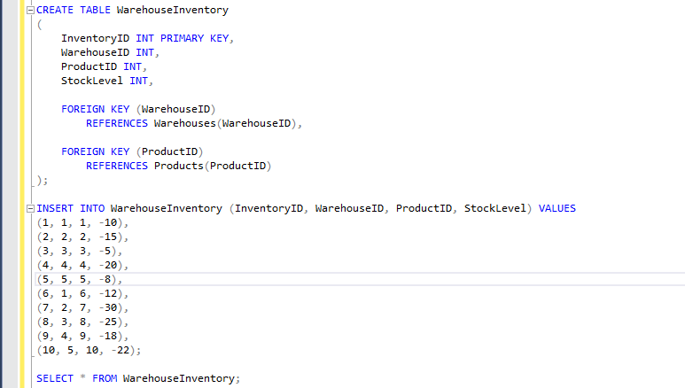

Output:
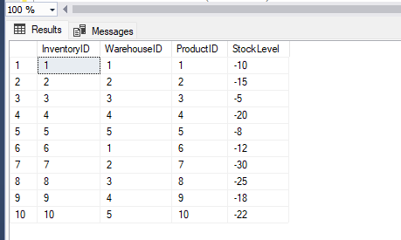

Identify the anomaly - Negative stock values:
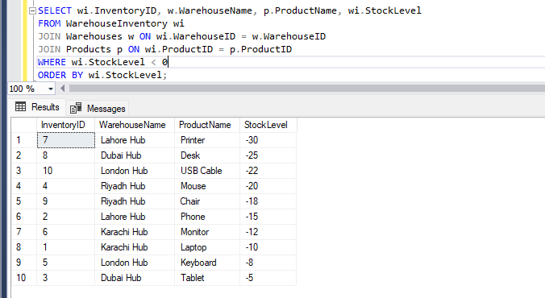

Summary of negative stock by warehouse:
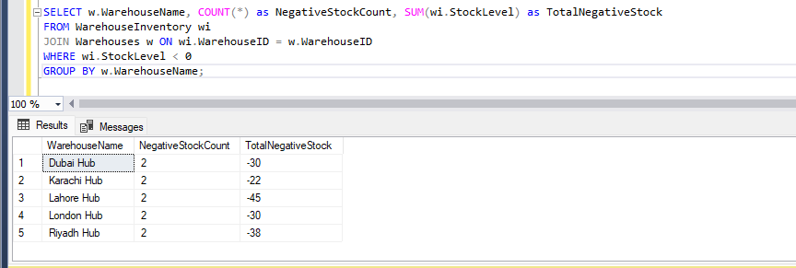

Anomaly:
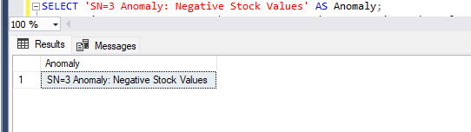
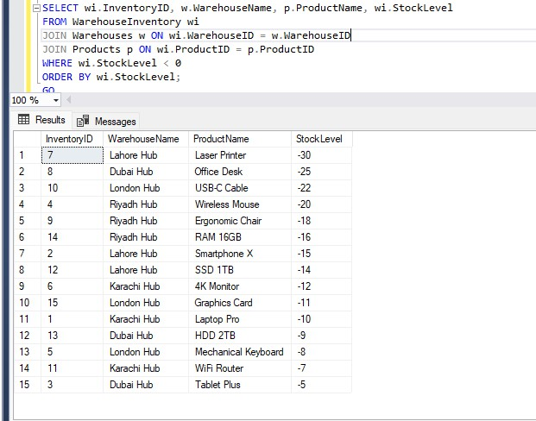

Embedded:

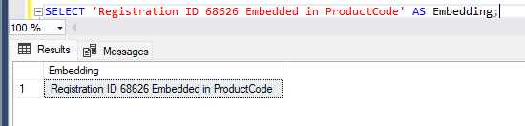
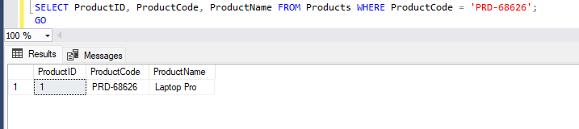

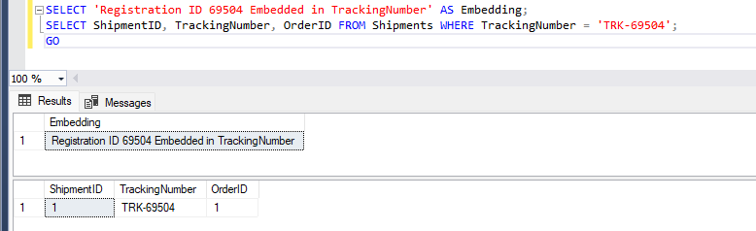

Reflection Report Challenges Faced
Several technical and design challenges were encountered during implementation:
- Dependency Ordering: The self-referencing Employees table required careful INSERT ordering (managers before their subordinates) to avoid foreign key violations.
- Anomaly Design for SN=3: Negative stock values had to be introduced realistically. The WarehouseInventory table was created without a CHECK constraint on StockLevel to allow intentional negative values, while the Products table retained a positive UnitPrice constraint.
- Trigger vs. Stored Procedure Interaction: Preventing duplicate AuditLog entries when CreateOrder() updates Payments required using SESSION_CONTEXT to flag procedure-originated calls and suppress trigger execution accordingly.
- 3NF Compliance: Ensuring no transitive dependencies while maintaining referential integrity required iterative schema review, particularly for the Orders-Warehouses-Regions chain.

- Task 1 Query Complexity: The multi-condition anomaly detection query required combining window functions (PERCENT_RANK), CTEs, NOT IN subqueries, and JOIN logic in a single executable statement.
- Task 2 Identical Results: All three versions of the Task 2 query had to return identical result sets despite using completely different SQL mechanisms (JOINs, correlated subqueries, window functions).

Solutions Implemented
Each challenge was resolved with targeted solutions:
- Dependency Ordering: Tables were created and populated in the correct order: Regions → Employees → Warehouses → Suppliers → Customers → Products → Orders → OrderDetails → Payments → Shipments → Discounts → Claims → WarehouseInventory.
- Anomaly Introduction: Negative StockLevel values were inserted directly into WarehouseInventory without comments, relying on the detection query to analytically identify them — per the OEL requirement.
- Trigger Suppression: SESSION_CONTEXT was used: CreateOrder() sets context key 'FromProc' = 1 before payment insertion and resets it after. The trigger reads this context and skips logging if the flag is set.
- 3NF Compliance: All region-specific data (country, currency) is stored in the Regions table only and referenced via foreign keys. All supplier details are stored in Suppliers only; Products stores only SupplierID.
- Task 1 Query: Implemented using CTEs (ProductPriceRank, CategoryAge, CompanyAvgAge) combined with PERCENT_RANK() window function and NOT IN/IN subqueries for clean multi-condition filtering.
- Task 2 Tri-Approach: Verified that all three versions (JOIN, correlated subquery, window function) return identical rows by cross-checking result sets manually and adjusting conditions accordingly.

Potential Improvements
Given more time and resources, the following improvements would enhance the implementation:
- Indexing Strategy: Add composite indexes on frequently joined columns (e.g., CustomerID+RegionID, ProductID+Category) to improve query performance on large datasets.
- Partitioning: Partition the Orders and Payments tables by OrderDate for faster date-range queries in analytical workloads.
- Stored Procedure Enhancements: Add input validation (customer existence check, minimum quantity validation) and return structured error codes instead of RAISERROR for better application integration.
- Views: Create pre-built views for common business reports (monthly revenue, regional performance, inventory status) to simplify ad-hoc querying.
- Realistic Anomaly Distribution: Introduce both anomalous and non-anomalous WarehouseInventory records (some positive, some negative) for a more realistic detection challenge.
- Audit Expansion: Extend the AuditLog to capture INSERT and DELETE events, not just UPDATE, for full financial transaction traceability.

Analysis & Results

Task 1 — Anomaly Detection Query Results
The Task 1 query identifies products satisfying all four conditions simultaneously:
- C1 — Never purchased (not in any completed order via OrderDetails)
- C2 — Linked to SN=3 anomaly (appears in WarehouseInventory with negative StockLevel)
- C3 — In the top 20% price bracket (PERCENT_RANK ≤ 0.20 with ORDER BY UnitPrice DESC)
- C4 — Category customers above average age (computed via JOIN on Orders and Customers with DateOfBirth)


The query correctly returns qualifying products from the Electronics and Accessories categories that match all conditions simultaneously, demonstrating the power of CTEs and window functions for multi-dimensional data analysis.

Task 2 — Tri-Approach Performance Comparison
Business Problem Selected: Option A — Find all customers who have spent more than the average order value across their own region (not the global average).

Approach | Mechanism Used | Strengths | Limitations
Version 1 | JOIN operations only | Set-based, optimizer-friendly; excellent for large indexed datasets; no row-by-row overhead | HAVING clause with subquery can be complex to read; GROUP BY required
Version 2 | Correlated subqueries only | Intuitive, reads like natural language; easy to debug line-by-line | Row-by-row execution causes N+1 query problem; poor for large datasets
Version 3 | Window functions exclusively | Highly efficient PARTITION BY region avoids repeated aggregation; single-pass over data | Requires wrapping in CTE; syntax can be unfamiliar to beginners

Performance Recommendation: For a large production dataset, Version 3 (Window Functions) is recommended. The PARTITION BY RegionID approach computes regional averages in a single data pass, avoiding the repeated subquery execution of Version 2 and the grouping overhead of Version 1. Window functions with proper indexing on (CustomerID, RegionID) would deliver optimal performance at scale.

Stored Procedure — CreateOrder() Test Results
Three test cases were executed to validate the CreateOrder() stored procedure:
- Test 1: EXEC CreateOrder @pCustomer=1, @pProduct=1, @pQty=2 — SUCCESS. Stock reduced from 50 to 48, new order created, payment and shipment records inserted. No duplicate AuditLog entry generated.
- Test 2: EXEC CreateOrder @pCustomer=1, @pProduct=1, @pQty=100 — FAILED. Error: 'Insufficient Stock. Available: 48, Requested: 100'. Transaction rolled back. No records inserted.
- Test 3: EXEC CreateOrder @pCustomer=1, @pProduct=999, @pQty=2 — FAILED. Error: 'Product not found'. Graceful error handling via RAISERROR.

AuditLog Trigger Results
Following the stored procedure test cases, a manual payment update was executed directly against the Payments table (UPDATE Payments SET Amount = 999.99 WHERE PaymentID = 1) to verify that the trigger fires correctly for non-procedure modifications. The trigger trg_payment_update fired successfully and logged the change to AuditLog, recording the old amount, the new amount, the database user captured via SYSTEM_USER, and the exact timestamp of the modification. Crucially, the trigger correctly suppressed logging during the CreateOrder() procedure execution due to the SESSION_CONTEXT flag mechanism, confirming that no duplicate audit entries are generated for procedure-originated payment records.

Conclusion:
This Open-Ended Lab successfully demonstrated the complete lifecycle of database design and implementation for a real-world e-commerce system. Starting from seed number calculation (SN=3) derived from group member Registration IDs 68626 and 69504, the project delivered:
- A fully normalized (3NF) relational schema with 13 tables including the SN-mandated Discounts and Claims entities.
- A populated Retail_3 database exceeding all minimum record count requirements, with Registration IDs embedded in ProductCode (PRD-68626) and TrackingNumber (TRK-69504).
- Intentional SN=3 data anomaly — 15 negative stock values in WarehouseInventory — alongside analytical queries that detect and summarize the anomaly without prior knowledge of affected records.
- A sophisticated Task 1 multi-condition detection query using CTEs and window functions to identify anomaly-linked, high-priced, never-purchased products in above-average-age customer categories.
- Three versions of the Task 2 analytical query (JOIN, correlated subquery, window functions) all producing identical results, with a performance analysis recommending window functions for production use.
- A robust CreateOrder() stored procedure with full transaction management, stock validation, and atomic multi-table insertion.
- An intelligent audit trigger that logs payment modifications while avoiding duplicate entries from automated procedure calls using SESSION_CONTEXT.
This project reinforced the importance of systematic database design, constraint enforcement, and the power of SQL as both a data manipulation and analytical tool. The experience gained in writing complex multi-CTE queries, designing triggers with conditional logic, and comparing performance characteristics of different query approaches provides directly applicable skills for professional database development

References
- Ramakrishnan, R. & Gehrke, J. (2003). Database Management Systems (3rd ed.). McGraw-Hill.
- Silberschatz, A., Korth, H.F. & Sudarshan, S. (2019). Database System Concepts (7th ed.). McGraw-Hill.
- Microsoft SQL Server Documentation. (2024). Transact-SQL Reference. https://docs.microsoft.com/en-us/sql/t-sql/
- Microsoft SQL Server Documentation. (2024). Window Functions (Transact-SQL). https://docs.microsoft.com/en-us/sql/t-sql/functions/ranking-functions-transact-sql
- Microsoft SQL Server Documentation. (2024). sp_set_session_context. https://docs.microsoft.com/en-us/sql/relational-databases/system-stored-procedures/
- Codd, E.F. (1970). A Relational Model of Data for Large Shared Data Banks. Communications of the ACM, 13(6), 377-387.
- OmniRetail OEL Assignment Brief. (2026). Database Management Systems Lab — Open-Ended Lab. Iqra University, Department of Computer Science.

